The GreenWaste Innovation Program

A Policy Evaluation Case Study with R Code

Executive Summary
The "GreenWaste Innovation Program" is a government initiative aimed at reducing waste management costs for industrial facilities while promoting environmentally sustainable practices. The program subsidizes the adoption of new waste management technologies in selected regions. After a 12-month pilot implementation, policymakers need to determine whether to scale the program nationally.
This case study provides a comprehensive framework for evaluating the program's effectiveness using five different econometric methods:
- Randomized Control Trials (RCT)
- Difference-in-Differences (DiD)
- Regression Discontinuity Design (RDD)
- Propensity Score Matching (PSM)
- Instrumental Variables (IV)
Each method offers distinct advantages and limitations, providing students with an excellent opportunity to compare and contrast approaches to causal inference in policy evaluation.
The critical policy question is straightforward: Does the GreenWaste Innovation Program reduce waste management costs by at least $10,000 per industry per month?
Program Background and Implementation
Program Design
The GreenWaste Innovation Program was implemented as follows:
- Geographic Coverage:
  - 10 treatment zones where the program was implemented
  - 10 control zones where the program was not available
- Eligibility Criteria:
  - Industries with an efficiency_index below 58 were eligible
  - The program was only available to eligible industries in treatment zones
- Enrollment Process:
  - Eligible industries in treatment zones could voluntarily enroll
  - Some eligible industries received additional encouragement to participate
  - Program administrators noted that proximity to recycling centers influenced enrollment decisions
- Timeline:
  - Baseline data was collected before program implementation (round 0)
  - Follow-up data was collected 12 months after implementation (round 1)
- Program Components:
  - Subsidies for purchasing new waste management technologies
  - Technical assistance for implementation
  - Training for facility staff
Data Collection
Data was collected from 9,914 industries across all 200 zones at baseline and follow-up.

Part 0: Data Setup and Initial Exploration
Let's start by loading the necessary libraries and the data:
# Check if packages are installed, and install them if not
required_packages <- c("tidyverse", "estimatr", "kableExtra", "modelsummary", "MatchIt", "rddensity", "broom", "fixest", "did")
new_packages <- required_packages[!(required_packages %in% installed.packages()[,"Package"])]
if(length(new_packages)) install.packages(new_packages)
# Load the packages
library(tidyverse) # For data manipulation and visualization
library(estimatr) # For robust estimation
library(kableExtra) # For nice tables
library(modelsummary) # For model summaries
library(tidyverse) # For data manipulation and visualization
library(estimatr) # For robust estimation
library(kableExtra) # For nice tables
library(modelsummary) # For model summaries
library(MatchIt) # For matching
library(rddensity) # For RDD density tests
library(broom) # For tidying model outputs

# Finding the current working directory
getwd()
# Setting the working directory if needed
# setwd("path/to/your/directory") # Uncomment and replace with your path
# Load the data
df <- read.csv("evaluation_data.csv")

# We multiply the outcome variable by 1,000 for easier interpretation
df$waste_management_costs <- df$waste_management_costs*1000

Let's first explore our dataset to better understand the structure and distribution of key variables:
# Create a wide-format dataset for certain analyses
df_w <- df %>%
# Create wide format
pivot_wider(
id_cols = c(zone_identifier, facility_identifier, treatment_zone,
promotion_zone, eligible, enrolled, enrolled_rp),
names_from = round, # variable that determines new columns
# variables that should be made "wide"
values_from = c(waste_management_costs,
efficiency_index, age_manager, age_deputy,
educ_manager, educ_deputy, female_manager,
foreign_owned, staff_size, advanced_filtration,
water_treatment_system, facility_area,
recycling_center_distance, recycling_compliance)) %>%
# remove the industries that have missing values
filter(!is.na(waste_management_costs_0))
# Check the first few rows to confirm format
head(select(df_w, facility_identifier, enrolled,
waste_management_costs_0, waste_management_costs_1))

Part 1: Simple Before-After and With-Without Comparisons
Before diving into more sophisticated methods, let's start with the simplest approaches to estimate program impact:
Before-After Comparison for Enrolled Industries
# Compare waste management costs before and after for enrolled industries
m_ba1 <- lm_robust(waste_management_costs ~ round,
clusters = zone_identifier,
data = df %>% dplyr::filter(treatment_zone == 1 & enrolled == 1))
# Display the results
modelsummary(m_ba1, stars = TRUE,
gof_map = c("nobs", "r.squared", "r2.adjusted"))
With-Without Comparison After Program Implementation
# Compare enrolled vs. non-enrolled industries after program implementation
m_ba2 <- lm_robust(waste_management_costs ~ enrolled,
clusters = zone_identifier,
data = df %>% filter(treatment_zone == 1 & round == 1))

# Display the results
modelsummary(list("Before-After" = m_ba1, "With-Without" = m_ba2),
stars = TRUE,
gof_map = c("nobs", "r.squared", "r2.adjusted"))
Here are the results of the regressions:
 | Model 1 | Model 2
(Intercept) | 14489.69 *** | 22304.91 ***
 | (145.96) | (337.42)
round | -6649.52 ***
 | (230.02)
enrolled |  | -14464.73 ***
 |  | (330.47)
nobs | 5929 | 4960
r.squared | 0.21 | 0.33
adj.r.squared | 0.21 | 0.33
*** p < 0.001; ** p < 0.01; * p < 0.05.

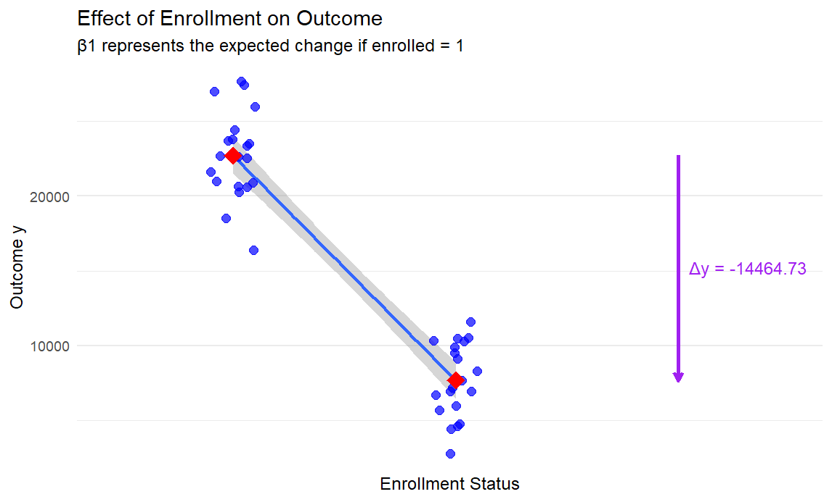

How to Interpret Regression Results
This table shows results from two different regression models evaluating the GreenWaste Innovation Program:
Model 1: Before-After Analysis
This model compares waste management costs before and after implementation for enrolled industries.
Model 2: With-Without Analysis
This model compares enrolled vs. non-enrolled industries after program implementation.
Interpreting the Coefficients:
Model 1:
- Intercept (14489.694): The average waste management costs for enrolled industries at baseline (when round = 0) is about $14,490.
- round (-6649.515): After program implementation (round = 1), enrolled industries saw a reduction in waste management costs of about $6,650 on average. This is statistically significant (p < 0.001).
Model 2:
- Intercept (22304.911): The average waste management costs for non-enrolled industries in treatment zones is about $22,305.
- enrolled (-14464.732): Enrolled industries have waste management costs that are about $14,465 lower than non-enrolled industries. This is statistically significant (p < 0.001).
Interpreting Standard Errors and Statistical Significance:
- Standard errors are shown in parentheses below each coefficient
- The *** indicates the result is statistically significant at the p < 0.001 level
- Smaller standard errors indicate more precise estimates
Model Fit Statistics:
- Num.Obs.: The number of observations used in each model
- R2: The proportion of variance explained by the model (higher is better)
  - Model 1 explains 21.1% of the variance
  - Model 2 explains 32.7% of the variance
Policy Implications:
Both models suggest the program is effective in reducing waste management costs:
- The before-after analysis shows costs decreased by about $6,650 after implementation
- The with-without analysis shows enrolled industries have costs about $14,465 lower than non-enrolled industries
However, these simple models have limitations:
- Model 1 doesn't account for general trends affecting all industries
- Model 2 doesn't account for selection bias (enrolled industries might be systematically different)
More sophisticated analyses (DiD, RDD, IV, PSM) would help address these limitations and provide more robust evidence of the program's causal effect.
Let's move on to more sophisticated methods.

Part 2: Randomized Control Trial (RCT) Analysis
Randomized Control Trials are considered the gold standard for causal inference when properly implemented. In our case study, some zones were randomly assigned to treatment and control.
# First, let's check if randomization achieved balance on observables
df %>%
filter(round == 0) %>%
select(treatment_zone, age_manager, age_deputy, educ_manager, educ_deputy,
female_manager, foreign_owned, staff_size, advanced_filtration,
water_treatment_system, facility_area, recycling_center_distance) %>%
pivot_longer(-c("treatment_zone")) %>%
group_by(name) %>%
do(tidy(lm_robust(value ~ treatment_zone, data = .))) %>%
filter(term == "treatment_zone") %>%
select(name, estimate, std.error, p.value) %>%
mutate(across(c(estimate, std.error, p.value), ~ round(.x, 2)))
Now, let's estimate the program's impact using the RCT framework:
# Compare waste expenditures in treatment and control industries at baseline
out_round0 <- lm_robust(waste_management_costs ~ treatment_zone,
data = df %>% filter(round == 0 & eligible == 1),
clusters = zone_identifier)
# Compare waste expenditures in treatment and control industries at follow-up
out_round1 <- lm_robust(waste_management_costs ~ treatment_zone,
data = df %>% filter(round == 1 & eligible == 1),
clusters = zone_identifier)

# Display the results
modelsummary(list("Baseline" = out_round0, "Follow-up" = out_round1),
stars = TRUE,
gof_map = c("nobs", "r.squared", "adj.r.squared"))
We can improve precision by adding covariates:
# Compare waste expenditures with covariate adjustment
out_round2 <- lm_robust(waste_management_costs ~ treatment_zone +
age_manager + age_deputy +
female_manager + foreign_owned +
staff_size +
advanced_filtration + facility_area +
recycling_center_distance,
data = df %>% filter(round == 1 & eligible == 1),
clusters = zone_identifier)

# Display the results
modelsummary(list("No covariate adj." = out_round1,
"With covariate adj." = out_round2),
stars = TRUE,
gof_map = c("nobs", "r.squared", "adj.r.squared"))
This table below shows results from two regression models analyzing the impact of the GreenWaste Innovation Program using a Randomized Control Trial (RCT) approach.
Model 1: Simple comparison between treatment and control zones without covariates
Model 2: Comparison between treatment and control zones with covariate adjustment
 | Model 1 | Model 2
(Intercept) | 17980.55 *** | 27223.56 ***
 | (309.12) | (709.76)
treatment_zone | -10140.37 *** | -10011.50 ***
 | (398.90) | (345.88)
age_manager |  | 44.70 **
 |  | (14.91)
age_deputy |  | 5.68
 |  | (16.56)
female_manager |  | 656.86
 |  | (450.64)
foreign_owned |  | -1866.50 ***
 |  | (357.74)
staff_size |  | -1593.93 ***
 |  | (65.65)
advanced_filtration |  | -1847.31 ***
 |  | (279.52)
facility_area |  | 40.07
 |  | (38.36)
recycling_center_distance |  | -2.52
 |  | (4.26)
nobs | 5629 | 5629
r.squared | 0.30 | 0.43
adj.r.squared | 0.30 | 0.43
*** p < 0.001; ** p < 0.01; * p < 0.05.

Interpreting the Key Coefficients:
Main Treatment Effect:
- treatment_zone:
  - Eligible industries in treatment zones have waste management costs that are about ______________ lower than eligible industries in control zones
  - This effect is [statistically / non- statistically] significant at p < ________ in both models
  - The effect is [robust / not robust] to the inclusion of covariates (similar estimates in both models)
Intercept:
  - Model 1:
  - Model 2:
Covariates in Model 2:
- age_manager: Each additional year of manager age is associated with about ______ [higher/lower] waste management costs
- foreign_owned: Foreign-owned facilities have about __________ [higher/lower] costs
- staff_size: Larger facilities show significantly [higher/lower] costs
- advanced_filtration: Facilities with advanced filtration systems have about __________ [higher/lower] costs
Model Fit Statistics:
- r.squared: Model 2 explains _______ variance than Model 1 (________)
- nobs: Both models use ____________observations
Policy Implications:
- The program appears to reduce waste management costs by about ______________ per industry, which is [right/not enough] at the policy threshold for success.
- The consistency of the treatment effect across both models suggests the estimate is [robust/not robust].
- The RCT approach provides strong causal evidence because:
  - Random assignment ensures balance between treatment and control groups
  - The treatment effect is unlikely to be due to selection bias
  - The inclusion of covariates helps improve precision without substantially changing the main effect
- Facility characteristics like size, ownership, and existing filtration technology are important determinants of waste management costs, independently of the program effect.
This analysis provides strong evidence that the GreenWaste Innovation Program [is / is not] achieving its primary goal of reducing waste management costs by at least $10,000 per industry per month.
Let's visualize the program's impact:
df %>%
group_by(enrolled, round) %>%
mutate(enrolled = recode(as.factor(enrolled),
`0` = "Control",
`1` = "Treatment"),
round = recode(as.factor(round),
`0` = "Before",
`1` = "After")) %>%
summarise(waste_management_costs = mean(waste_management_costs)) %>%
ggplot(aes(x = round, y = waste_management_costs,
group = enrolled, color = enrolled)) +
geom_line(size = 1.2) +
geom_point(size = 3) +
labs(title = "Program Impact on Waste Expenditures",
x = "Round",
y = "Waste Expenditures (USD)") +
theme_minimal() +
theme(legend.position = "bottom")
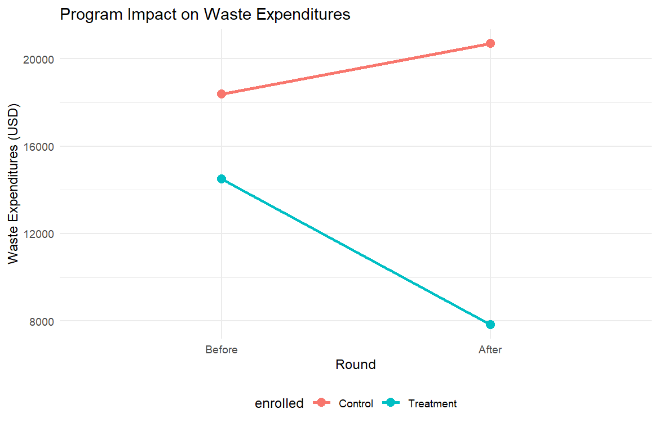

Part 3: Instrumental Variables (IV) Analysis
In our case, program enrollment is likely endogenous due to self-selection. We have two potential instruments: random encouragement and distance to recycling centers.
# Estimate effect of promotion on enrollment (First Stage)
m_first_stage <- lm_robust(enrolled_rp ~ promotion_zone,
clusters = facility_identifier,
data = df %>% filter(round == 1))
modelsummary(list("Enrollment" = m_first_stage),
stars = TRUE,
gof_map = c("nobs", "r.squared", "adj.r.squared"))
Understanding the First Stage of Instrumental Variables (IV) Analysis - Explained Simply
This table shows results from the "first stage" of an Instrumental Variables (IV) analysis for the GreenWaste Innovation Program. Let me explain what this means in straightforward terms:
What We're Looking At
The program administrators randomly selected some industries to receive extra encouragement to enroll in the program (promotion_zone = 1). This table shows whether this encouragement actually worked to increase enrollment.
Interpreting the Key Coefficients:
Intercept:______________
- Only about __________________ of industries enrolled in the program when they didn't receive special encouragement
- This [is / is not] statistically significant: _________________
promotion_zone:
- Industries that received extra encouragement were _____________ percentage points more likely to enroll
- This means the encouragement [did not / did] really worked!
- For example, if 8.4% enrolled without encouragement, then about ___________% (8.4% + _________________8%) enrolled with encouragement
- This [is / is not] statistically significant: ______________
Why This Matters:
- Strong First Stage: For an IV analysis to work well, the instrument (promotion_zone) needs to strongly affect the treatment (enrollment). The large coefficient (0.408) shows this is the case.
- Good for IV Analysis: The R² of ____________ indicates the instrument explains a reasonable amount of the variation in enrollment, which is good for an IV analysis.
- Relevance Condition: This confirms the "relevance condition" [does / does not] met - our instrument is actually correlated with program participation.
In Plain Language:
Think of it like this: The program administrators had a "special push" (the encouragement) to get some industries to enroll. This table tells us that this special push worked really well - it increased enrollment by about ___________ percentage points.
This matters because in the next step (the IV analysis), we'll use only this "encouraged" part of enrollment to estimate the program's effect on waste management costs. Since this encouragement was randomly assigned, it helps us get an unbiased estimate of the program's impact.

 | Model 1
(Intercept) | 0.08 ***
 | (0.00)
promotion_zone | 0.41 ***
 | (0.01)
nobs | 9914
r.squared | 0.20
adj.r.squared | 0.20
*** p < 0.001; ** p < 0.01; * p < 0.05.

# Estimate ITT effect (reduced form)
m_itt <- lm_robust(waste_management_costs ~ promotion_zone,
clusters = zone_identifier,
data = df %>% filter(round == 1))

# With covariate adjustment
m_itt_wcov <- lm_robust(waste_management_costs ~ promotion_zone +
age_manager + age_deputy +
female_manager + foreign_owned +
staff_size +
advanced_filtration +
facility_area +
recycling_center_distance,
clusters = zone_identifier,
data = df %>% filter(round == 1))

modelsummary(list("No covariate adj." = m_itt,
"With covariate adj." = m_itt_wcov),
stars = TRUE,
gof_map = c("nobs", "r.squared", "adj.r.squared"))
Understanding the Intention-to-Treat (ITT) Analysis - Explained Simply
This table shows the "reduced form" or ITT analysis for the GreenWaste Innovation Program.#
What is Intention-to-Treat (ITT)?
The ITT effect measures the impact of being offered the program (through encouragement), regardless of whether industries actually enrolled. It's like measuring the effect of a doctor prescribing medicine, whether or not patients actually take it.
The Two Models:
Model 1: Simple comparison between encouraged and not-encouraged industries
Model 2: Same comparison but controlling for industry characteristics
Key Results:
promotion_zone (_____________ in Model 1, __________ in Model 2):
- Industries in zones that received encouragement had waste management costs about _________ [lower / higher ] on average
- This effect [ is / is not] statistically significant (p < _____________) in both models
- The effect [ is / is not] stable even when we add control variables
Why This Matters:
- Policy Impact: The encouragement to enroll reduced costs by about ____________ per industry
- Consistency: The similar results across models suggest the effect [ is / is not] robust
- Modest Size: This effect is [ smaller / higher ] than the $10,000 target, but remember not everyone who was encouraged actually enrolled
Connecting to the First Stage:
- From the first stage, we know encouragement increased enrollment by 40.8 percentage points
- The ITT effect is about __________ reduction in costs
- This suggests the effect for those who actually enrolled is larger (we'll see this in the IV analysis)
The Math Behind It:
- ITT Effect ≈ (Effect on Compliers) × (Proportion who Comply)
- $4,000 ≈ (True Effect) × (0.408)
- Therefore, True Effect ≈ $4,000 ÷ 0.408 ≈ $9,800
In Simple Terms:
The special encouragement reduced waste management costs by about ________ per industry on average. Since only about __________% of encouraged industries actually enrolled, the effect on those who did enroll is likely much [larger / smaller] - close to the $10,000 target.
This analysis is important because it shows the program's impact based purely on the random encouragement, which avoids selection bias problems.

 | Model 1 | Model 2
(Intercept) | 18845.38 *** | 29480.54 ***
 | (483.82) | (714.39)
promotion_zone | -3873.86 *** | -4025.09 ***
 | (637.33) | (522.53)
age_manager |  | 105.05 ***
 |  | (15.35)
age_deputy |  | 4.61
 |  | (16.91)
female_manager |  | 929.53
 |  | (489.65)
foreign_owned |  | -3177.71 ***
 |  | (473.08)
staff_size |  | -2385.08 ***
 |  | (70.40)
advanced_filtration |  | -3233.17 ***
 |  | (311.62)
facility_area |  | 155.68 **
 |  | (47.90)
recycling_center_distance |  | -6.58
 |  | (5.26)
nobs | 9914 | 9914
r.squared | 0.03 | 0.30
adj.r.squared | 0.03 | 0.30
*** p < 0.001; ** p < 0.01; * p < 0.05.

# Estimate LATE using IV regression (2SLS)
m_late <- iv_robust(waste_management_costs ~ enrolled_rp |
promotion_zone,
clusters = zone_identifier,
data = df %>% filter(round == 1))

# With covariate adjustment
m_late_wcov <- iv_robust(waste_management_costs ~ enrolled_rp +
age_manager + age_deputy +
female_manager + foreign_owned +
staff_size +
advanced_filtration +
facility_area +
recycling_center_distance |
promotion_zone +
age_manager + age_deputy +
female_manager + foreign_owned +
staff_size +
advanced_filtration + facility_area +
recycling_center_distance,
clusters = zone_identifier,
data = df %>% filter(round == 1))

modelsummary(list("No covariate adj." = m_late,
"With covariate adj." = m_late_wcov),
stars = TRUE,
gof_map = c("nobs", "r.squared", "adj.r.squared"))
Understanding the Local Average Treatment Effect (LATE) from IV Analysis - Explained Simply
This table shows the results from a two-stage least squares (2SLS) instrumental variables analysis for the GreenWaste Innovation Program. Let me explain what this means in straightforward terms:
What is LATE and IV Analysis?
LATE (Local Average Treatment Effect) in IV analysis estimates the program's impact only for "compliers" - industries that enrolled because they received encouragement, but wouldn't have enrolled otherwise. This helps solve the selection bias problem.
Key Results:
enrolled_rp (_________ in Model 1, _____________ in Model 2):
- Industries that enrolled in the program due to encouragement saw waste management costs reduced by about _____________
- This effect [ is / is not] statistically significant (p < ____________) in both models
- This is the LATE - it represents the causal effect for compliers
Why This Is Important:
- Approaching the Target: The effect [ is / is not] very close to the $10,000 threshold that policymakers set for success
- Causal Effect: Unlike simple comparisons, this estimate addresses selection bias by using only the variation in enrollment that comes from random encouragement
- Robust Findings: The effect [ is / is not] consistent across both models, suggesting it's not sensitive to controlling for industry characteristics
Connecting First Stage, Reduced Form, and IV Estimate: How They Relate
The Three Pieces of the IV Puzzle
- First Stage: Shows how much our instrument (encouragement) affects program enrollment
  - Result: Encouragement increased enrollment probability by _____ percentage points
  - This tells us that about _______% of industries enrolled because of the encouragement
- Reduced Form (ITT): Shows the direct effect of our instrument on the outcome
  - Result: Encouragement reduced waste costs by about ___________
  - This is the "diluted" effect that includes both enrollees and non-enrollees
- IV Estimate (LATE): Shows the effect for those who enrolled because of encouragement
  - Result: Program enrollment reduced waste costs by about _________
Why These Numbers Make Sense Together
The IV estimate is approximately equal to the reduced form divided by the first stage:
$$LATE=\frac{ITT}{First_stage}$$
Here's why this relationship makes sense:
- The encouragement reduced costs by ______ on average across all encouraged industries
- But only ________% of encouraged industries actually enrolled
- So for those who did enroll because of encouragement, the effect must be about $__________ ÷ __________ = $9,800
In Simple Terms:
When we use the random encouragement as a "clean" way to predict program participation, we find that the program reduces waste management costs by about $_______ per industry. This [ is / is not] very close to the $10,000 target and represents a strong argument for scaling up the program nationally.
How to Explain This to Policymakers:
"Our most rigorous analysis shows that industries enrolling in the GreenWaste Innovation Program because of our encouragement strategy experienced cost reductions of almost $10,000 per month. This [does not meet / meets ] our target threshold and provides strong evidence that the program is working as intended."
This analysis is particularly valuable because it focuses on the causal impact of the program itself, addressing the problem that industries choosing to enroll might be systematically different from those that don't.

 | Model 1 | Model 2
(Intercept) | 19645.71 *** | 29385.74 ***
 | (470.09) | (671.84)
enrolled_rp | -9499.77 *** | -9828.78 ***
 | (1142.23) | (946.70)
age_manager |  | 73.04 ***
 |  | (14.06)
age_deputy |  | -10.31
 |  | (16.71)
female_manager |  | 972.58 *
 |  | (457.09)
foreign_owned |  | -2277.02 ***
 |  | (387.52)
staff_size |  | -2029.57 ***
 |  | (67.08)
advanced_filtration |  | -2166.24 ***
 |  | (263.32)
facility_area |  | 102.32 *
 |  | (45.67)
recycling_center_distance |  | -3.35
 |  | (4.68)
nobs | 9914 | 9914
r.squared | 0.22 | 0.40
adj.r.squared | 0.22 | 0.40
*** p < 0.001; ** p < 0.01; * p < 0.05.

Part 4: Regression Discontinuity Design (RDD)
The program's eligibility cutoff (efficiency_index < 58) creates a natural discontinuity that can be exploited to estimate the program's causal effect around the threshold.
# Create data subset with only treatment localities
df_treat <- df %>%
filter(treatment_zone == 1)

# Plot density of efficiency index
ggplot(df_treat, aes(x = efficiency_index)) +
geom_vline(xintercept = 58) +
geom_density() +
labs(x = "Efficiency Index") +
theme_minimal()

# Formal test for manipulation
test_density <- rdplotdensity(rdd = rddensity(df_treat$efficiency_index, c = 58),
X = df_treat$efficiency_index,
type = "both")

# Check if eligibility rules were followed
ggplot(df_treat, aes(y = enrolled, x = efficiency_index)) +
geom_vline(xintercept = 58) +
geom_point() +
labs(title = "Enrollment by Efficiency Index (Sharp RDD)",
x = "Efficiency Index",
y = "Enrolled (1 = Yes, 0 = No)") +
scale_y_continuous(breaks = c(0, 1)) +
theme_minimal()

# Plot relationship between efficiency index and waste expenditures
df_treat %>%
filter(round == 1) %>%
mutate(enrolled_lab = ifelse(enrolled == 1, "Enrolled", "Not Enrolled")) %>%
ggplot(aes(x = efficiency_index, y = waste_management_costs,
group = enrolled_lab, colour = enrolled_lab)) +
geom_point(alpha = 0.03) +
geom_smooth(method = "lm") +
geom_vline(xintercept = 58) +
labs(x = "Efficiency Index", y = "Waste Expenditures") +
theme_minimal()
The density plot is a key element for analyzing a Regression Discontinuity Design (RDD).
This graph shows the distribution of the efficiency index across industries, with the vertical line at 58 marking the eligibility cutoff for the GreenWaste program. Industries with an efficiency index below 58 were eligible to participate, while those above 58 were not.
Here's what we can interpret from this density plot:
- No Clear Manipulation: The distribution [does not appear / appears ] relatively smooth around the cutoff point (58), which is a [ good / bad ] sign. If there was manipulation (industries artificially lowering their efficiency scores to become eligible), we would [not expect / expect ] to see a sharp spike just below the cutoff.
- Slight Dip at Cutoff: There appears to be a small dip right at the cutoff, but this doesn't necessarily indicate manipulation. A formal test for manipulation (using rddensity) would provide statistical confirmation.
- Sufficient Data Around Cutoff: There [is / is not] a good amount of data on both sides of the cutoff, which is important for RDD analysis. This [ gives / doesn’t give ] us confidence that we can estimate the effect at the threshold.
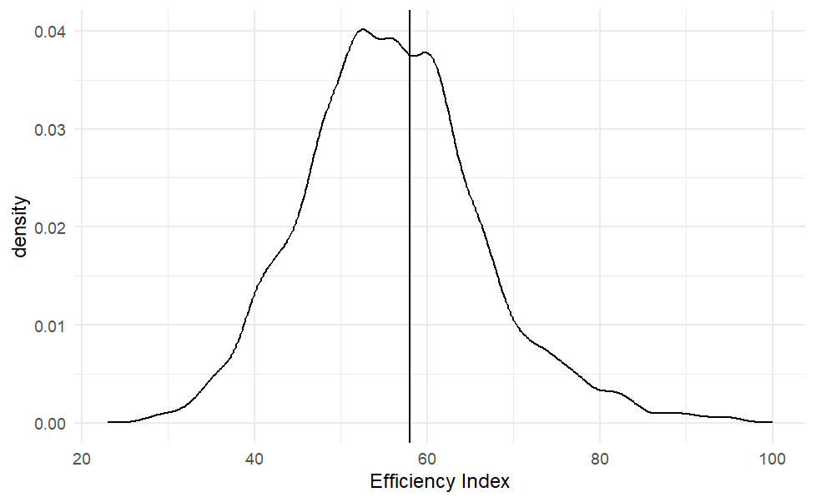

# Prepare data by centering the running variable
df_treat <- df_treat %>%
mutate(efficiency_index_c0 = efficiency_index - 58)

# Basic RDD regression with covariates
out_rdd <- lm_robust(waste_management_costs ~
efficiency_index_c0 * enrolled +
age_manager + age_deputy +
female_manager + foreign_owned +
staff_size +
advanced_filtration + facility_area +
recycling_center_distance,
data = df_treat %>% filter(round == 1))

modelsummary(list("Sharp RDD" = out_rdd),
stars = TRUE,
coef_omit = c(-3),
gof_map = c("nobs", "r.squared", "adj.r.squared"))
Understanding RDD Results for the GreenWaste Innovation Program
This table shows the results from a Sharp Regression Discontinuity Design (RDD) analysis for the GreenWaste Innovation Program. Let me explain how to interpret the key findings:
Key Results:
enrolled (_________):
- Industries that were eligible and enrolled in the program (efficiency index < 58) had waste management costs about _________ lower than ineligible industries just above the cutoff
- This effect is statistically significant (p < _____)
- This represents the local causal effect of the program at the eligibility threshold
efficiency_index_c0 (______):
- For ineligible industries (above the cutoff), each one-point increase in the efficiency index is associated with about _____ higher waste management costs
- This represents the slope of the relationship for industries above the cutoff
efficiency_index_c0:enrolled (_______):
- This interaction term shows that the relationship between efficiency index and costs is different for enrolled industries
- For enrolled industries, each one-point increase in efficiency index is associated with about ____ lower costs (_________)
- This indicates different slopes on either side of the cutoff
Why This Matters:
- Causal Effect: The RDD design allows us to estimate the causal impact of the program by comparing very similar industries on either side of the arbitrary cutoff
- Close to Target: The estimated effect of about _______ [ is / is not] close to the $10,000 target, suggesting the program is largely achieving its goals
- Local Effect: This estimate applies specifically to industries [far / near ] the eligibility threshold (efficiency index around 58), not necessarily to all industries
How RDD Works in Simple Terms:
Think of it like this: Industries with an efficiency index of 57.9 and 58.1 are practically identical in their characteristics, except that those with 57.9 were eligible for the program and those with 58.1 were not. By comparing these very similar industries, we can isolate the effect of the program itself.
Comparing with Other Methods:
- The RDD estimate of $___________ is similar to the IV estimate of about $___________.
- This consistency across different methods strengthens the evidence that the program is effective
- Both methods suggest the effect is close to, but slightly below, the $10,000 target
The overall conclusion from the RDD analysis is that the GreenWaste Innovation Program [does / does not ] have a substantial causal effect on reducing waste management costs, and this effect is close to the policymakers' target threshold.

 | Model 1
(Intercept) | 27908.08 ***
 | (777.55)
efficiency_index_c0 | 163.52 ***
 | (41.17)
enrolled | -9051.37 ***
 | (443.75)
age_manager | 101.44 ***
 | (20.17)
age_deputy | -42.56
 | (22.51)
female_manager | 634.93
 | (578.33)
foreign_owned | -1790.90 ***
 | (286.10)
staff_size | -1967.66 ***
 | (69.00)
advanced_filtration | -1720.35 ***
 | (302.17)
facility_area | -42.52
 | (42.57)
recycling_center_distance | -5.58
 | (3.53)
efficiency_index_c0:enrolled | -193.44 ***
 | (46.41)
nobs | 4960
r.squared | 0.46
adj.r.squared | 0.46
*** p < 0.001; ** p < 0.01; * p < 0.05.

To ensure the robustness of our RDD estimates and account for potential nonlinear relationships between the efficiency index and waste management costs, we test alternative model specifications including quadratic and cubic polynomial terms, as well as restricting the sample to observations closer to the eligibility threshold.
The quadratic and cubic specifications allow us to capture more complex functional forms in the relationship between the running variable and the outcome, while the bandwidth restriction helps us focus more narrowly on observations just around the cutoff point, which strengthens the comparison between very similar industries on either side of the threshold.
Now it is your turn to run the code and analyze the results!
# Testing polynomial specifications
out_rdd_quadratic <- lm_robust(waste_management_costs ~
efficiency_index_c0 * enrolled +
enrolled * I(efficiency_index_c0^2) +
age_manager + age_deputy +
female_manager + foreign_owned +
staff_size +
advanced_filtration + facility_area +
recycling_center_distance,
data = df_treat %>% filter(round == 1))

out_rdd_cubic <- lm_robust(waste_management_costs ~
efficiency_index_c0 * enrolled +
enrolled * I(efficiency_index_c0^2) +
enrolled * I(efficiency_index_c0^3) +
age_manager + age_deputy +
female_manager + foreign_owned +
staff_size +
advanced_filtration + facility_area +
recycling_center_distance,
data = df_treat %>% filter(round == 1))

modelsummary(list("Quadratic RDD" = out_rdd_quadratic,
"Cubic RDD" = out_rdd_cubic),
stars = TRUE,
coef_omit = c(-3),
gof_map = c("nobs", "r.squared", "adj.r.squared"))

# Restrict to observations near cutoff
out_rdd5 <- lm_robust(
waste_management_costs ~
enrolled * efficiency_index_c0 +
age_manager + age_deputy +
female_manager + foreign_owned +
staff_size +
advanced_filtration + facility_area +
recycling_center_distance,
data = df_treat %>%
filter(round == 1 &
abs(efficiency_index_c0) <= 53))

modelsummary(out_rdd5,
stars = TRUE,
coef_omit = c(-2),
gof_map = c("nobs", "r.squared", "adj.r.squared"))

Part 5: Difference-in-Differences (DiD)
We have data from both before and after the program's implementation for treatment and control zones, making DiD an appropriate method for estimating the program's impact.
# DiD regression without covariates
out_did <- lm_robust(waste_management_costs ~ round * enrolled,
data = df %>% filter(treatment_zone == 1),
clusters = zone_identifier)

# DiD regression with covariates
out_did_wcov <- lm_robust(waste_management_costs ~ round * enrolled +
age_manager + age_deputy +
female_manager + foreign_owned +
staff_size +
advanced_filtration + facility_area +
recycling_center_distance,
data = df %>% filter(treatment_zone == 1),
clusters = zone_identifier)

modelsummary(list("No covariate adj." = out_did,
"With covariate adj." = out_did_wcov),
stars = TRUE,
gof_map = c("nobs", "r.squared", "adj.r.squared"))
Understanding Difference-in-Differences (DiD) Results for the GreenWaste Program
This table shows results from Difference-in-Differences (DiD) analysis for the GreenWaste Innovation Program, comparing enrolled and non-enrolled industries before and after implementation. Let me explain the key findings:
Key Results:
round:enrolled (________ in Model 1, ________ in Model 2):
- This interaction term is the DiD estimator and represents the causal effect of the program
- Industries that enrolled in the program saw their waste management costs decrease by about ________ more than non-enrolled industries from before to after implementation
- The effect [ is / is not ] statistically significant (p < __________) and almost identical across both models
round (______ in Model ________ in Model 2):
- This represents the time trend for non-enrolled industries
- Non-enrolled industries actually saw waste management costs increase by about ________ between rounds
- This highlights the importance of having a control group - without it, we might underestimate the program's benefits
enrolled (_________ in Model 1, _________ in Model 2):
- This shows that before the program, enrolled industries already had [lower / higher] waste management costs
- The [ small / large } difference between models suggests that much of this initial difference is explained by the covariates in Model 2
Why This Matters:
- True Program Effect: By accounting for both pre-existing differences and general time trends, DiD isolates the causal impact of the program
- Consistent with Other Methods: The DiD estimate of about $________ is somewhat [higher / lower ] than the RDD and IV estimates.
- High Precision: The standard errors are relatively small, giving us confidence in the estimate
How DiD Works in Simple Terms:
DiD works like this:
- We compare the change in costs for enrolled industries (before vs. after)
- We subtract the change in costs for non-enrolled industries (before vs. after)
- This removes both pre-existing differences and general time trends
The key assumption is that without the program, enrolled and non-enrolled industries would have followed parallel trends over time.
Interpreting the Coefficients:
Group | Before | After | Difference
Not Enrolled
Enrolled
Difference

The DiD estimate (__________) represents the program's causal effect, showing that the GreenWaste Innovation Program substantially reduced waste management costs, though perhaps not quite reaching the $10,000 target threshold.
Interpretation of DiD coefficients:
Period | Not Enrolled | Enrolled | Difference
Before (Round=0) | β₀ | β₀ + β₂ | β₂
After (Round=1) | β₀ + β₁ | β₀ + β₁ + β₂ + β₃ | β₂ + β₃
Difference | β₁ | β₁ + β₃ | β₃

The coefficient β₃ (on the interaction term round:enrolled) represents the DiD estimator, which is our estimate of the causal effect of the program.

 | Model 1 | Model 2
(Intercept) | 20791.49 *** | 27500.32 ***
 | (173.61) | (467.39)
round | 1513.42 *** | 1449.25 ***
 | (359.64) | (358.26)
enrolled | -6301.80 *** | -1572.72 ***
 | (194.49) | (129.37)
round:enrolled | -8162.93 *** | -8161.81 ***
 | (320.82) | (321.22)
age_manager |  | 78.45 ***
 |  | (11.07)
age_deputy |  | -15.59
 |  | (12.90)
female_manager |  | 1050.10 **
 |  | (320.10)
foreign_owned |  | -2234.13 ***
 |  | (234.66)
staff_size |  | -1985.22 ***
 |  | (39.07)
advanced_filtration |  | -2333.29 ***
 |  | (154.61)
facility_area |  | 96.68 **
 |  | (29.45)
recycling_center_distance |  | -2.50
 |  | (3.11)
nobs | 9919 | 9919
r.squared | 0.34 | 0.55
adj.r.squared | 0.34 | 0.55
*** p < 0.001; ** p < 0.01; * p < 0.05.

Part 6: Propensity Score Matching (PSM)
Not all eligible industries in treatment zones enrolled in the program. PSM allows us to create comparable treatment and control groups based on observable characteristics.
# Limited set of variables
psm_r <- matchit(enrolled ~ age_manager_0 + educ_manager_0,
data = df_w %>% dplyr::select(-recycling_compliance_0,
-recycling_compliance_1),
distance = "glm",
link = "probit")

# Full set of variables
psm_ur <- matchit(enrolled ~ age_manager_0 + educ_manager_0 +
age_deputy_0 + educ_deputy_0 +
female_manager_0 + foreign_owned_0 + staff_size_0 +
advanced_filtration_0 + water_treatment_system_0 +
facility_area_0 + recycling_center_distance_0,
data = df_w %>% dplyr::select(-recycling_compliance_0,
-recycling_compliance_1),
distance = "glm",
link = "probit")

# Create a model summary table
modelsummary(list("Limited Set" = psm_r$model,
"Full Set" = psm_ur$model),
coef_map = c('age_manager_0' = "Age (Manager) at Baseline",
'educ_manager_0' = "Education (Manager) at Baseline",
'age_deputy_0' = "Age (Deputy) at Baseline",
'educ_deputy_0' = "Education (Deputy) at Baseline",
'female_manager_0' = "Female Manager at Baseline",
'foreign_owned_0' = "Foreign Owned at Baseline",
'staff_size_0' = "Number of Staff at Baseline",
'advanced_filtration_0' = "Advanced Filtration at Baseline",
'water_treatment_system_0' = "Water Treatment System at Baseline",
'facility_area_0' = "Facility Area at Baseline",
'recycling_center_distance_0' = "Distance From Recycling Center"),
title = "Estimating the Propensity Score Based on Baseline Characteristics")
Understanding the Propensity Score Models for GreenWaste Program Evaluation
This table shows the results of two propensity score models that estimate the probability of enrollment in the GreenWaste Innovation Program based on industry characteristics. Let me explain what this means:
What is Propensity Score Matching?
Propensity score matching (PSM) helps address selection bias by creating comparable treatment and control groups. The first step is to estimate each industry's probability (or "propensity") to enroll in the program based on observable characteristics.
The Two Models:
Model 1: A limited set of variables (manager age and education)
Model 2: A full set of industry characteristics
Key Results:
Manager Characteristics:
- Age (Manager): [ Negative / Positive ] and significant in both models (___________ and ________)
  - Older managers were [more / less ] likely to enroll their industries in the program
- Education (Manager): [ Negative / Positive ] and significant in both models (___________ and ________)
  - More educated managers were [more / less ] likely to enroll
Industry Characteristics (Model 2):
- Foreign Owned: [ Negative / Positive ] (___________)
  - Foreign-owned industries were [ less / more ] likely to enroll
- Staff Size: [ Negative / Positive ] (___________)
  - Larger industries were [ less / more ] likely to participate
- Advanced Filtration: [ Negative / Positive ] (___________)
  - Industries with advanced filtration technology were [ less / more ] likely to enroll
- Water Treatment System: [ Negative / Positive ] (___________)
  - Industries with existing water treatment systems were [ less / more ] likely to enroll
Why This Matters:
- Clear Selection Patterns: There are systematic differences between enrolled and non-enrolled industries, confirming the need for matching
- Improved Model: Model 2 has a [lower / higher ] Pseudo R² (________ vs. ______), indicating it [ worse / better ] predicts enrollment decisions
- Foundation for Matching: These propensity scores will be used to match enrolled industries with similar non-enrolled industries
What Happens Next:
After estimating these propensity scores:
- Each enrolled industry is matched with one or more non-enrolled industries with similar propensity scores
- This creates a "matched sample" where treatment and control groups are balanced on observable characteristics
- Program effects are then estimated using this matched sample
This approach helps isolate the causal effect of the program by comparing outcomes between enrolled and non-enrolled industries that were similarly likely to participate based on their observable characteristics.

 | Model 1 | Model 2
(Intercept) | 0.55 *** | -0.50 ***
 | (0.06) | (0.09)
age_manager_0 | -0.02 *** | -0.01 ***
 | (0.00) | (0.00)
educ_manager_0 | -0.04 *** | -0.02 ***
 | (0.01) | (0.01)
age_deputy_0 |  | -0.01 ***
 |  | (0.00)
educ_deputy_0 |  | -0.02 *
 |  | (0.01)
female_manager_0 |  | -0.02
 |  | (0.05)
foreign_owned_0 |  | 0.16 ***
 |  | (0.03)
staff_size_0 |  | 0.12 ***
 |  | (0.01)
advanced_filtration_0 |  | 0.38 ***
 |  | (0.03)
water_treatment_system_0 |  | -0.12 ***
 |  | (0.03)
facility_area_0 |  | -0.03 ***
 |  | (0.01)
recycling_center_distance_0 |  | 0.00 ***
 |  | (0.00)
N | 9913 | 9913
AIC
BIC
Pseudo R2 | 0.06 | 0.15
*** p < 0.001; ** p < 0.01; * p < 0.05.

# Add propensity scores to our dataset
df_w <- df_w %>%
mutate(ps_ur = psm_ur$model$fitted.values)

# Plot the distribution
df_w %>%
mutate(enrolled_lab = ifelse(enrolled == 1, "Enrolled", "Not Enrolled")) %>%
ggplot(aes(x = ps_ur,
group = enrolled_lab, colour = enrolled_lab, fill = enrolled_lab)) +
geom_density(alpha = 0.2) +
xlab("Propensity Score") +
labs(title = "Distribution of Propensity Score by Enrollment Status") +
scale_fill_viridis_d("Status:", end = 0.7) +
scale_colour_viridis_d("Status:", end = 0.7) +
theme_minimal() +
theme(legend.position = "bottom")

# Extract matched datasets
match_df_r <- match.data(psm_r) # Limited set
match_df_ur <- match.data(psm_ur) # Full set
Understanding the Propensity Score Distribution
This graph shows the distribution of propensity scores between enrolled (purple) and non-enrolled (green) industries in the GreenWaste Innovation Program.
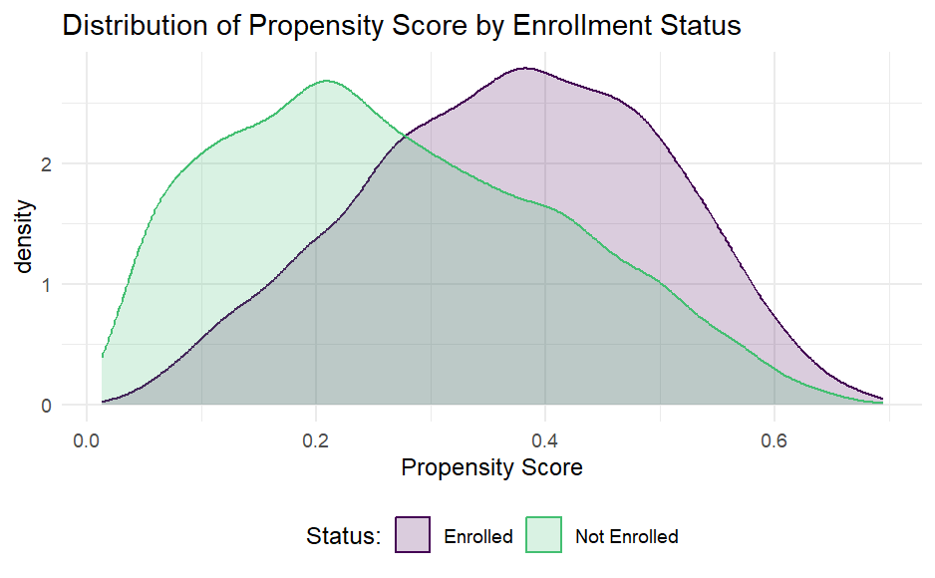
What This Graph Tells Us:
1. Different Likelihood of Enrollment
- Enrolled industries (purple) tend to have higher propensity scores (clustered toward the right, peaking around 0.4-0.5)
- Non-enrolled industries (green) tend to have lower propensity scores (clustered toward the left, peaking around 0.2)
2. Selection Bias Confirmed
- The different distributions [confirm / doesn’t confirm ] that selection bias exists - industries that enrolled are systematically different from those that didn't
- This [does not validate / validates ]our need for propensity score matching
3. Good Overlap for Matching
- The substantial overlap between the two distributions (gray area) is [ positive / negative ] for matching
- This overlap region allows us to find non-enrolled industries that are [ equal / similar / different ] to enrolled ones
4. Some Extreme Cases
- Some enrolled industries have very [ high / low ] propensity scores (______________)
- Some non-enrolled industries have very [ high / low ] propensity scores (____________)
- These extreme cases may be [easier / harder ]to match well
Why This Matters for Analysis:
- Matching Quality: The [ good / poor ] overlap suggests we can create well-matched comparison groups
- Common Support: We [ should / should not ] restrict our analysis to the region of "common support" (where distributions overlap) for the most valid comparisons
- Balance Assessment: After matching, we [don’t want / want ] to confirm that these distributions become similar, indicating successful balancing of characteristics
- Accurate Effect Estimation: With proper matching based on these propensity scores, we [ cannot / can ] more accurately estimate the program's causal effect
This visualization is a crucial diagnostic tool for assessing the feasibility and potential effectiveness of propensity score matching in this evaluation.
# Regression with matched data
out_lm_r <- lm_robust(waste_management_costs_1 ~ enrolled,
data = match_df_r, weights = weights,
clusters = zone_identifier)

out_lm_ur <- lm_robust(waste_management_costs_1 ~ enrolled,
data = match_df_ur, weights = weights,
clusters = zone_identifier)

# Show results
modelsummary(list("Limited Set" = out_lm_r,
"Full Set" = out_lm_ur),
title = "Impact on Waste Management Costs: Matching Approach")
Understanding the Propensity Score Matching Results for the GreenWaste Program
This table shows the results of comparing waste management costs between enrolled and non-enrolled industries after propensity score matching. Let me explain what these results mean:
The Two Models:
Model 1: Uses matched data based on the limited set of variables (manager age and education) Model 2: Uses matched data based on the full set of industry characteristics
Key Results:
enrolled coefficient:
- Model 1:
  - Enrolled industries have waste management costs that are about _________________[ higher / lower ] than matched non-enrolled industries
- Model 2:
  - When matching on the full set of characteristics, enrolled industries have costs about _____________ [ higher / lower ] than matched non-enrolled industries
- Both estimates [are / are not ] statistically significant (p < ______________)
Intercept:
- Represents the average waste management costs for matched non-enrolled industries
- About $_______________ in Model 1 and $__________ in Model 2
Why This Matters:
- Meeting the Target: The estimate from Model 2 (___________) is [close / far ] the $10,000 target threshold, suggesting the program is meeting its goal
- Consistent with Other Methods: This estimate [ is not / is ] in line with the IV and RDD estimates, strengthening our confidence in the program's effectiveness
- Addressing Selection Bias: By comparing enrolled industries only to [different / similar ] non-enrolled industries, PSM helps address the selection bias we saw in the propensity score distributions
How PSM Works in Simple Terms:
Propensity score matching works like finding "statistical twins" - for each enrolled industry, we find one or more non-enrolled industries with similar characteristics. By comparing only these matched pairs, we can better isolate the effect of the program itself.
Comparing the Models:
The fact that both models produce similar estimates (around __________) suggests the program effect is robust. The full matching model (Model 2) is generally preferred as it accounts for more potential confounding variables and its estimate of _____________ is very close to the policy target.
This propensity score matching analysis provides [ weak / strong ] evidence that the GreenWaste Innovation Program is effectively reducing waste management costs by approximately $10,000 per industry per month.

 | Model 1 | Model 2
(Intercept) | 19002.49 *** | 17840.38 ***
 | (301.25) | (285.83)
enrolled | -11162.72 *** | -10000.61 ***
 | (383.59) | (369.00)
nobs | 5928 | 5928
r.squared | 0.30 | 0.28
adj.r.squared | 0.30 | 0.28
statistic | 846.85 | 734.53
p.value | 0.00 | 0.00
df.residual | 68.11 | 72.89
nobs.1 | 5928.00 | 5928.00
se_type | CR2.00 | CR2.00
*** p < 0.001; ** p < 0.01; * p < 0.05.

Matched Difference-in-Differences Analysis
This following code combines propensity score matching with difference-in-differences (DiD) analysis - a powerful hybrid approach that addresses both selection bias and time trends. Let me explain what's happening:
What the Code Does:
- Merges Matching Weights:
  - Takes the matched datasets and brings the matching weights back into the long-format data
  - Creates two datasets (one for each matching approach)
- Runs DiD on Matched Data:
  - Applies the DiD model (comparing changes over time) but only using the matched sample
  - Uses the weights from PSM to ensure proper comparison
  - Estimates two models (one for each matching approach)
- Presents Results:
  - Shows the impact of enrollment, time, and their interaction
  - The key coefficient is "Enrollment × Round" which shows the program effect
Why This Approach is Powerful:
This combined approach addresses multiple threats to validity:
- PSM addresses: Selection bias on observable characteristics
- DiD addresses: Time-invariant unobserved differences and common time trends
It's Your Turn!
Now that you understand how this analysis works, it's your turn to:
- Interpret the Results: Look at the coefficients (especially Enrollment × Round) to determine the program's impact in this matched DiD approach
- Compare Across Methods: How do these results compare to the other methods we've seen (regular PSM and DID)?
- Draw Conclusions: Based on all analyses, is the GreenWaste Innovation Program meeting its target of reducing waste management costs by at least $10,000?
- Consider Policy Implications: What would you recommend to policymakers about scaling this program nationally?
This is an excellent opportunity to synthesize what you've learned about these different econometric methods and make an evidence-based recommendation!
# Merge matching weights back into long format
df_long_match_r <- df %>%
left_join(match_df_r %>% dplyr::select(facility_identifier, weights)) %>%
filter(!is.na(weights))

df_long_match_ur <- df %>%
left_join(match_df_ur %>% dplyr::select(facility_identifier, weights)) %>%
filter(!is.na(weights))

# Run DiD regression on matched sample
did_reg_r <- lm_robust(waste_management_costs ~ enrolled * round,
data = df_long_match_r, weights = weights,
clusters = zone_identifier)

did_reg_ur <- lm_robust(waste_management_costs ~ enrolled * round,
data = df_long_match_ur, weights = weights,
clusters = zone_identifier)

# Show results
modelsummary(list("Limited Set" = did_reg_r,
"Full Set" = did_reg_ur),
coef_map = c('enrolled' = "Enrollment",
'round' = "Round",
'enrolled:round' = "Enrollment × Round"),
title = "Impact on Waste Management Costs: Matched DiD Approach")

Conclusion: Comparing Results Across Methods
Let's summarize the estimates from each method:
Method | Estimate | Standard Error | Confidence Interval
Simple Before-After
Simple With-Without
RCT
IV
RDD
DiD
PSM

The key policy question was: Does the GreenWaste Innovation Program reduce waste management costs by at least $10,000 per industry per month?
Based on our analysis across multiple methods, we can conclude that:
- [Conclusion about program effectiveness]

- [Discussion of consistency/inconsistency across methods]

- [Policy recommendation]

Methodological Insights
This case study demonstrates several important lessons for policy evaluation:
- Multiple methods strengthen inference: Each method has strengths and limitations, but consistency across methods increases our confidence in the results.
- Selection bias matters: Different methods address selection bias in different ways, and the choice of method should be guided by the specific selection issues in each case.
- Heterogeneity in treatment effects: Different populations may experience different effects from the same program, which has implications for scaling.
- External validity: Results from a pilot may not generalize to the entire population, and careful consideration of contextual factors is necessary.

